**Bookstore Database Project phase 1 Report**

**Project Title**:

* Bookstore Database

**Course**:

* CSC380

**Team Members**:

* مهند الشهراني - 442100744
* Yasir Alfaifi - 444100878
* سلمان ال الشيخ - 444105684

**2. Table of Contents**

1. Introduction
2. Project Description
3. ER Diagram
4. Relational Schema
5. SQL Scripts
6. Description of the Environment
7. User Interface and Queries
8. Conclusion

**3. Introduction**

This project focuses on designing and implementing a bookstore database management system. The database handles various entities such as **Books**, **Categories**, **Customers**, **Orders**, and **Payment Information**. It provides a systematic way to organize and manage books, customer orders, and payments for an online bookstore.

**4. Project Description**

This section includes a detailed explanation of each entity and the relationships:

**Book**:  
The **Book** entity stores information about the books available in the bookstore, including attributes like Book_id, title, author, isbn, and price. It has a **many-to-one relationship** with **Category** and a **many-to-many relationship** with **Order** (through the **Books_in_Order** relationship).

**Category**:  
The **Category** entity categorizes books by genres. Each category can have multiple books, establishing a **one-to-many relationship** with **Book**.

**Customer**:  
The **Customer** entity represents individuals purchasing from the bookstore. A **Customer** can place multiple orders, creating a **one-to-many relationship** with **Order**.

**Order**:  
The **Order** entity tracks customer purchases. An order can include multiple books (**many-to-many relationship** with **Book**), and each order has a single customer (**one-to-many relationship** with **Customer**). It also has a **one-to-one relationship** with **Payment_Info**.

**Payment_Info**:  
This entity stores payment details associated with each order, establishing a **weak one-to-one relationship** with **Order**.

**Books_in_Order**:  
This is a junction entity that represents the **many-to-many relationship** between **Order** and **Book**. It tracks the quantity of each book in an order.

**Summary of Relationships**:

* **Book ↔ Category**: Many-to-One
* **Order ↔ Book**: Many-to-Many
* **Order ↔ Customer**: Many-to-One
* **Order ↔ Payment_Info**: One-to-One

**5. ER Diagram**

Here is the **ER diagram** used in the project:

Using sql workbench:

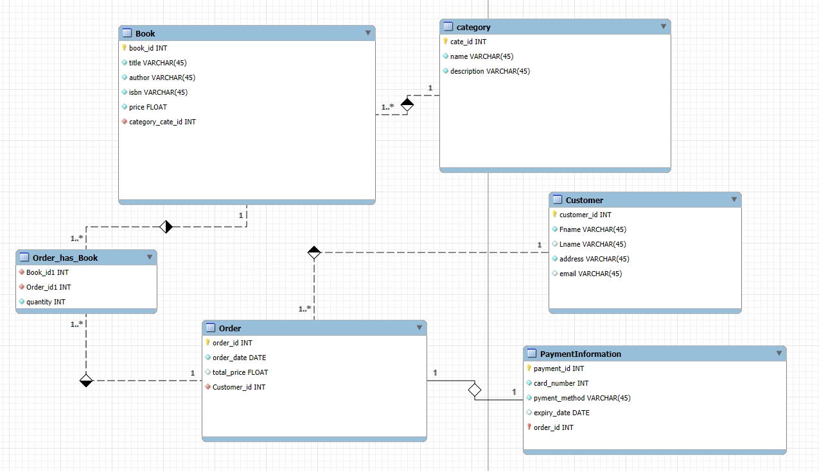

**6. Relational Schema**

The relational schema was mapped from the ER diagram, and the structure includes the following tables:

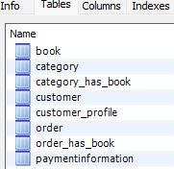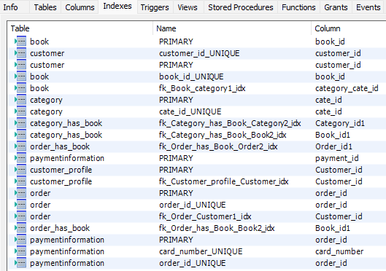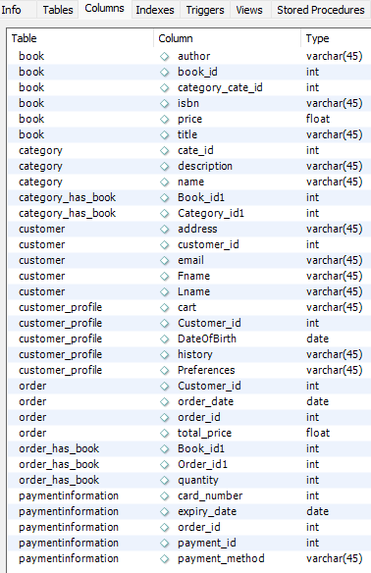Using sql workbench:

**7. SQL Script:**

SET @OLD_UNIQUE_CHECKS=@@UNIQUE_CHECKS, UNIQUE_CHECKS=0;

SET @OLD_FOREIGN_KEY_CHECKS=@@FOREIGN_KEY_CHECKS, FOREIGN_KEY_CHECKS=0;

SET @OLD_SQL_MODE=@@SQL_MODE, SQL_MODE='ONLY_FULL_GROUP_BY,STRICT_TRANS_TABLES,NO_ZERO_IN_DATE,NO_ZERO_DATE,ERROR_FOR_DIVISION_BY_ZERO,NO_ENGINE_SUBSTITUTION';

-- -----------------------------------------------------

-- Drop Tables (If Exists)

-- -----------------------------------------------------

DROP TABLE IF EXISTS Category;

DROP TABLE IF EXISTS Book;

DROP TABLE IF EXISTS Customer;

DROP TABLE IF EXISTS `Order`;

DROP TABLE IF EXISTS PaymentInformation;

DROP TABLE IF EXISTS Order_has_Book;

-- -----------------------------------------------------

-- Schema mydb

-- -----------------------------------------------------

CREATE SCHEMA IF NOT EXISTS `mydb` DEFAULT CHARACTER SET utf8;

USE `mydb`;

-- -----------------------------------------------------

-- Table `category`

-- -----------------------------------------------------

CREATE TABLE IF NOT EXISTS `mydb`.`category` (

`cate_id` INT NOT NULL,

`name` VARCHAR(45) NOT NULL,

`description` VARCHAR(45) NOT NULL,

PRIMARY KEY (`cate_id`),

UNIQUE INDEX `cate_id_UNIQUE` (`cate_id` ASC) VISIBLE)

ENGINE = InnoDB;

-- -----------------------------------------------------

-- Table `Book`

-- -----------------------------------------------------

CREATE TABLE IF NOT EXISTS `mydb`.`Book` (

`book_id` INT NOT NULL,

`title` VARCHAR(45) NOT NULL,

`author` VARCHAR(45) NOT NULL,

`isbn` VARCHAR(45) NOT NULL,

`price` FLOAT NOT NULL,

`category_cate_id` INT NOT NULL,

PRIMARY KEY (`book_id`),

UNIQUE INDEX `book_id_UNIQUE` (`book_id` ASC) VISIBLE,

INDEX `fk_Book_category1_idx` (`category_cate_id` ASC) VISIBLE,

CONSTRAINT `fk_Book_category1`

FOREIGN KEY (`category_cate_id`)

REFERENCES `mydb`.`category` (`cate_id`)

ON DELETE NO ACTION

ON UPDATE NO ACTION)

ENGINE = InnoDB;

-- -----------------------------------------------------

-- Table `Customer`

-- -----------------------------------------------------

CREATE TABLE IF NOT EXISTS `mydb`.`Customer` (

`customer_id` INT NOT NULL,

`Fname` VARCHAR(45) NOT NULL,

`Lname` VARCHAR(45) NULL,

`address` VARCHAR(45) NOT NULL,

`email` VARCHAR(45) NULL,

PRIMARY KEY (`customer_id`),

UNIQUE INDEX `customer_id_UNIQUE` (`customer_id` ASC) VISIBLE)

ENGINE = InnoDB;

-- -----------------------------------------------------

-- Table `Order`

-- -----------------------------------------------------

CREATE TABLE IF NOT EXISTS `mydb`.`Order` (

`order_id` INT NOT NULL,

`order_date` DATE NOT NULL,

`total_price` FLOAT NULL,

`Customer_id` INT NOT NULL,

PRIMARY KEY (`order_id`),

INDEX `fk_Order_Customer1_idx` (`Customer_id` ASC) VISIBLE,

UNIQUE INDEX `order_id_UNIQUE` (`order_id` ASC) VISIBLE,

CONSTRAINT `fk_Order_Customer1`

FOREIGN KEY (`Customer_id`)

REFERENCES `mydb`.`Customer` (`customer_id`)

ON DELETE NO ACTION

ON UPDATE NO ACTION)

ENGINE = InnoDB;

-- -----------------------------------------------------

-- Table `Order_has_Book`

-- -----------------------------------------------------

CREATE TABLE IF NOT EXISTS `mydb`.`Order_has_Book` (

`Book_id1` INT NOT NULL,

`Order_id1` INT NOT NULL,

`quantity` INT NOT NULL,

INDEX `fk_Order_has_Book_Book2_idx` (`Book_id1` ASC) VISIBLE,

INDEX `fk_Order_has_Book_Order2_idx` (`Order_id1` ASC) VISIBLE,

CONSTRAINT `fk_Order_has_Book_Book2`

FOREIGN KEY (`Book_id1`)

REFERENCES `mydb`.`Book` (`book_id`)

ON DELETE NO ACTION

ON UPDATE NO ACTION,

CONSTRAINT `fk_Order_has_Book_Order2`

FOREIGN KEY (`Order_id1`)

REFERENCES `mydb`.`Order` (`order_id`)

ON DELETE NO ACTION

ON UPDATE NO ACTION)

ENGINE = InnoDB;

-- -----------------------------------------------------

-- Table `PaymentInformation`

-- -----------------------------------------------------

CREATE TABLE IF NOT EXISTS `mydb`.`PaymentInformation` (

`payment_id` INT NOT NULL,

`card_number` INT NOT NULL,

`payment_method` VARCHAR(45) NOT NULL,

`expiry_date` DATE NULL,

`order_id` INT NOT NULL,

PRIMARY KEY (`order_id`, `payment_id`),

UNIQUE INDEX `card_number_UNIQUE` (`card_number` ASC) VISIBLE,

UNIQUE INDEX `order_id_UNIQUE` (`order_id` ASC) VISIBLE,

CONSTRAINT `payment_id`

FOREIGN KEY (`order_id`)

REFERENCES `mydb`.`Order` (`order_id`)

ON DELETE NO ACTION

ON UPDATE NO ACTION)

ENGINE = InnoDB;

-- Reset SQL Modes

SET SQL_MODE=@OLD_SQL_MODE;

SET FOREIGN_KEY_CHECKS=@OLD_FOREIGN_KEY_CHECKS;

SET UNIQUE_CHECKS=@OLD_UNIQUE_CHECKS;